

FIS Loan Services Data Hub

Quick Start Guide
Legal Information
Copyright © 2026 FIS™ and/or its subsidiaries. All Rights Reserved.
This software documentation manual has been provided pursuant to a license agreement containing restrictions on its use. This document contains confidential and trade secret information of FIS and/or its subsidiaries and is protected by Federal copyright law. It may not be copied or distributed in any form or medium, disclosed to third parties, or used in any manner not authorized in said license agreement except with prior written authorization from FIS.

Last Update
This document was last updated on 4/2/2026.

Contents
Introduction 4
FIS Loan Services Suite Data Model and Flow Overview 4
Data Model Architecture 4
Data Flow 4
Company or Deal Setup 4
Portfolio Snapshot Data 4
Cashflow Snapshot Data 6
Ratings, Market Prices, and Compliance Tests 6
Data Access Validation 6
FIS Loan Services Suite Data Model Details 6
Dimension Tables 6
Working with FIS Loan Services Suite: Quick Start Queries 9
Portfolio Snapshot Compliance 9
Accessing FIS Loan Services Suite 12
Automation and Scheduling 13
FIS Loan Services Suite Database Structure 13
Database Details 13
Replication Frequency and Time Series 13
Sixth Street Partners Portfolio and Compliance Guidance 14
Support and Resources 16

Introduction
The FIS Loan Service Suite Data Hub is available to clients, providing secure, direct, and high-performance access to Portfolio Snapshot, Cashflow Snapshot, and related Compliance Datasets.
The key benefits include:
- Providing fast, direct, and comprehensive access to all your FIS Loan Services Suite data.
- With a star schema data model, your information is organized for efficient analytics and easy reporting.
- With Snowflake, you retrieve normalized data and experience high performance with large datasets.

FIS Loan Services Suite Data Model and Flow Overview

Data Model Architecture
FIS Loan Service Suite data is replicated from the FIS CDO Suite into your dedicated Snowflake client database. The data is set up using a star schema, with one table connected to several smaller tables. This makes it easier to analyze and report on the data quickly.

Data Flow
- Data is generated and approved in CDO Suite and replicated hourly into your Snowflake instance.
- Give secure read-only access to the data in Snowflake.

Company or Deal Setup
- Company Setup: Ensure your company is registered in the CDO Suite.
- Deal Linking: Deals must be linked to your company and have a valid "Role in Deal":
Role in Deal Code | Role in Deal Description
CM | Collateral Manager
FA | Fund Administrator
- Active and inactive deals are available in Snowflake.

Portfolio Snapshot Data
- Definition: Point-in-time datasets detail such as balances, contracts, and referential data.
- Identification: Each snapshot is identified by a unique ps_id.
- Classifications: Only approved snapshots with the following codes are available:
Code | Description
MR | Monthly Report
INT | Interim Report
PR | Payment Report
IR | Effective Date Report
HR | Hypothetical Report
ER | Escrow Report
OR | Original Report
QR | Quarterly Report
1IT | 1st Interim Target
2IT | 2nd Interim Target
LA | Last Approved Snapshot
DIN | Daily Initial
DPT | Daily Pre-trade
WK | Weekly Report
- Set up: You can create Portfolio Snapshots manually or via automation.

Cashflow Snapshot Data
- Definition: Point-in-time cash datasets that include account summaries and unrecorded cash.
- Identification: Each snapshot is identified by a unique cs_id.
- Approved Classification:
Code | Description
APR | Approved - Cashflow
- Set up: Created in CDO Suite and made available in Snowflake upon approval.

Ratings, Market Prices, and Compliance Tests
- Ratings/Market Prices: Require an appropriate rating agency or pricing subscriptions for your company.
- Compliance Tests: The Compliance test results are enabled for display in Snowflake. The compliance team will configure these in CDO Suite within the FIS Loan Services Suite Deal Dashboard.

Data Access Validation
- During onboarding, FIS validates that:
  - Portfolio/Cashflow Snapshots are accessible for approved IDs linked to your ENTITY_IDs.
  - Compliance test results and DEAL_TEST_IDs are visible.

FIS Loan Services Suite Data Model Details
Portfolio Snapshot and Cashflow snapshot data have been transferred into a dimensional data model as a part of the replication process from CDO Suite to Snowflake. This restructuring organizes the data more effectively and enhances its accessibility once it becomes available.

Dimension Tables
- FIS Loan Services Suite database contains logical dimensional tables that arrange data in logical hierarchies, making related information organized and easy to find.
The following dimensional tables are available:
Dimension Tables Table Views
VW_DEAL_INCLUDED_TEST
VW_DIM_ACCOUNT
VW_DIM_DEAL
VW_DIM_DEAL_TEST
VW_DIM_PORTFOLIO_SNAPSHOT
VW_FACT_PORTFOLIO_SNAPSHOT_TEST_SUMMARY
VW_FACT_PS_DEAL_DATA
VW_PORTFOLIO_SNAPSHOT_CASH_ACCOUNT_BALANCES

- Navigation:
- Go to SNOWFLAKE > VIRTUS_INFOMART > VIEWS.
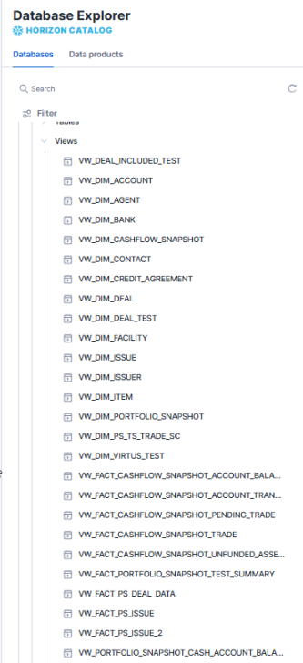
- Each view provides Description, Contacts, Privileges, Columns (with metadata), Data Preview, and Lineage.

Working with FIS Loan Services Suite: Quick Start Queries
To help you get started, below are some Quick Start queries for the FIS Loan Services Suite. These queries are designed to provide fast access to key portfolio snapshot data, such as compliance test summaries and cash account balances.

Portfolio Snapshot Compliance

Test Summary - All Tests
Purpose: Retrieve the top 1000 compliance test summary results for all deals and portfolio snapshots. Each row represents a test within a portfolio snapshot.
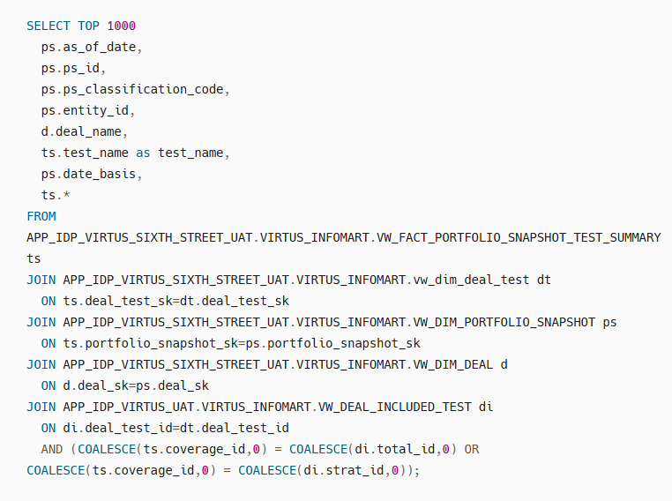

Test Summary - Failed Test
Purpose: Retrieve the top 1000 compliance test summary results that are Fail for all deals and portfolio snapshots. Each row represents a failed test within a portfolio snapshot.
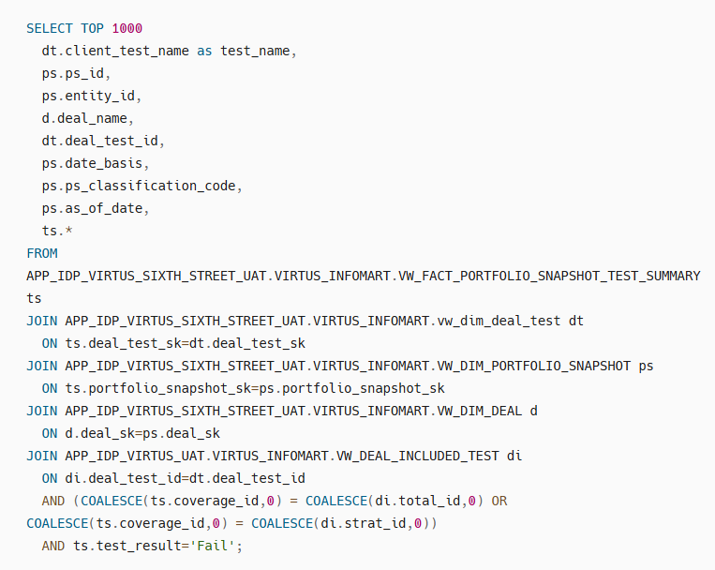

Snapshot Date Basis - Cash Account Balances
Purpose: Retrieve the top 1000 active cash account balances as of the portfolio snapshot date basis. Each row represents a cash account within a deal.
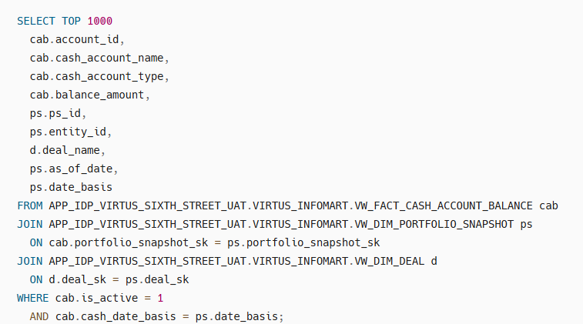

Snapshot Date Basis - Transaction date Basis
Purpose: Return the top 1000 cash account balances by transaction date for all deals and portfolio snapshots. Only snapshots run at activation time are included. Each row represents a cash account within a deal.
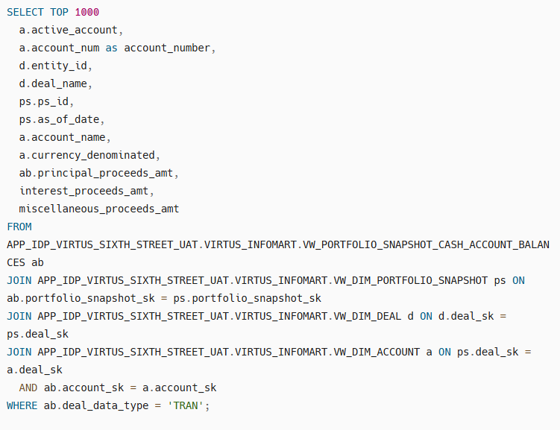

Accessing FIS Loan Services Suite
The following are the steps:
- Log in to your Snowflake instance.
- Navigate to Projects > Worksheets > Shared with me
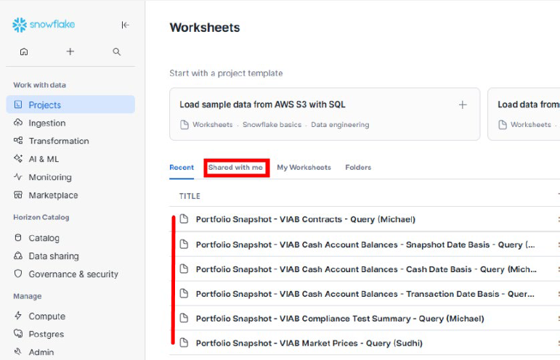
- Select the relevant query.
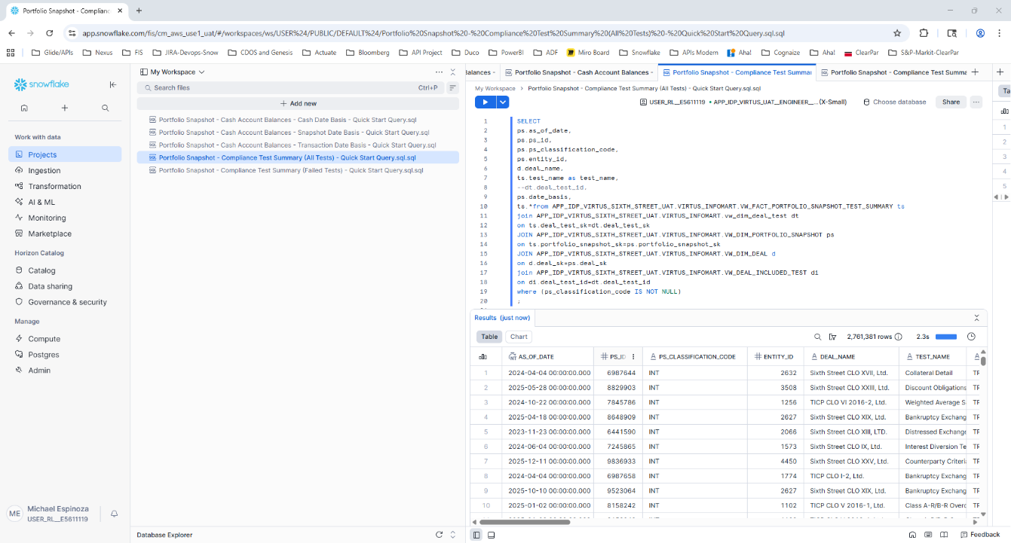
- Click the Run button to execute.
These queries provide ready-made access to common Portfolio and Cashflow Snapshot data layouts that are used by FIS Loan Services Suite clients.

Automation and Scheduling
Snowflake offers tasks that allow you to automate and schedule query execution. For more information, refer Snowflake Tasks Documentation

FIS Loan Services Suite Database Structure
Data stored within a Sixth Street Partners database, which FIS Loan Services Suite shares with you via a client private listing.

Database Details
- Database Name: APP_IDP_VIRTUS_SIXTH_STREET ( a unique client database name)
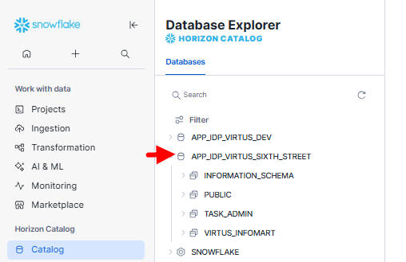
- Structure:
  - INFORMATION_SCHEMA
  - PUBLIC
  - TASK_ADMIN
  - VIRTUS_INFOMART

Replication Frequency and Time Series
- Replication: Database stores replicated data from the CDO Suite, which is hourly replicated.
- Time Series Columns:
  - EFFECTIVE_START_DATE: Record’s effective start.
  - EFFECTIVE_END_DATE: Record’s effective end.
  - IS_CURRENT_RECORD: Boolean, indicates current status.
  - IS_DELETE: Boolean, indicates if record is deleted.
  - FACT_UPDATED_AT: Last updated timestamp.
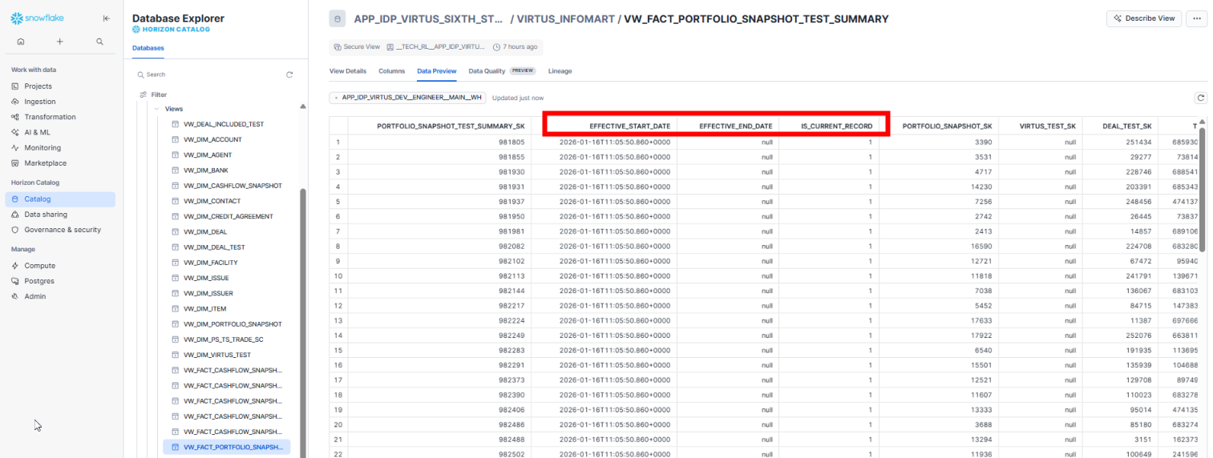
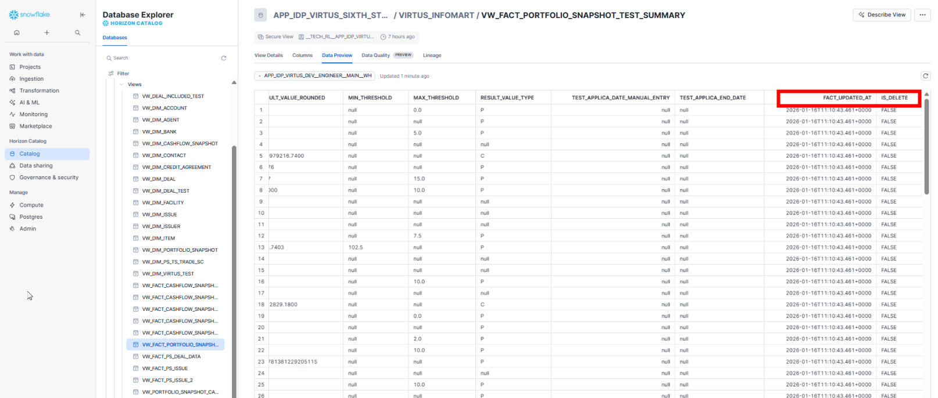

Sixth Street Partners Portfolio and Compliance Guidance
Note: This section is very specific to the Sixth Street Partners client.
The key guidelines for Sixth Street Partners on Portfolio Snapshots and Compliance Test Results are:
- Portfolio Snapshot Date Basis
The deal portfolio snapshots are typically created on a Trade Date Basis, which is visible in multiple locations in Data Hub within W_DIM_PORTFOLIO_SNAPSHOT.
- Classic FTP Compliance Test Results Process
Outside of Data Hub, Sixth Street Partners receives a daily compliance test results file via FTP using a job set up in CDO Suite. Each day's file is saved for records. The job works as follows:
- FTP job runs and creates an approved Trade Date Basis Portfolio Snapshot with an Interim Report classification for all deals in the job.
- The compliance test results are derived from the most recent approved portfolio snapshot for each deal and:
- The Approved Portfolio Snapshot must have an As of Date on or before the date the FTP job runs.
- The Approved Portfolio Snapshot must not have a classification code of ‘DPT’ for the Daily Payment Report. This logic can be replicated in Data Hub.

Support and Resources
- Snowflake Support: FISDataHub@fisglobal.com
- Documentation Portal: FIS Capital Market Documentation

